RRN

CONTINUOUS ASSESSMENT TEST - 1
OCTOBER / NOVEMBER 2025

Programme & Branch | : | B.Tech AI & ML
Semester | : | I | Date & Session | : | 27/10/2025 & AN
Course Code & Name | : | MAE 1161-Mathematics for Computer Science
Duration | : | 90 minutes | Maximum Marks | : | 50

ANSWER ALL QUESTIONS
PART A (5 X 2 = 10 MARKS) |  |  |  | CO | KL
 |  | Convert 67 into its binary equivalent. |  | CO1 | KL3
 |  | Define rotation transformation. Explain with an example? |  | CO2 | KL2
 |  | Define injective and surjective functions with examples. |  | CO1 | KL1
 |  | A 3 x 3 matrix A has eigenvalues 4,5 and 7. Find the determinant of the matrix A. |  | CO2 | KL2
 |  | Find the rank of the matrix  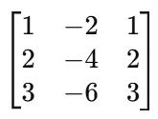 |  | CO2 | KL3
PART B (2 X 16 = 32 MARKS) |  |  |  | CO | KL
6. a | (i) | Convert (AF)₁₆ to binary, octal, and decimal with full steps. | (8) | CO1 | KL1
 | (ii) | Verify whether R={(1,2),(2,3),(1,3)} on set A = {1,2,3} is transitive, symmetric, and reflexive. | (8) | CO1 | KL4
(OR)
b | (i) | Determine the Modular Inverse of 17 mod 43 using the Extended Euclidean Algorithm. | (8) | CO1 | KL3
 | (ii) | Find 7¹²⁸ mod 13 using Modular Exponentiation. | (8) | CO1 | KL3
7.a |  | For the following Matrix, verify the Cayley Hamilton theorem and find A⁻¹ using it.  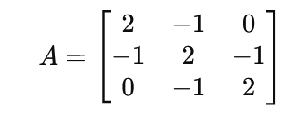 | (16) | CO2 | KL3
(OR)
b | (i) | Explain Linear Transformation with examples of scaling and reflection in 2D space. | (6) | CO2 | KL2
 | (ii) | Consider the following matrix A  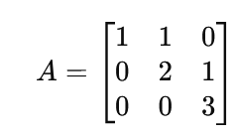  A) Find the Eigenvalues and Eigenvectors of A  B) Show that the matrix A has an inverse using the Eigenvalues and state the property.  C) Without computing A^{-1,} find its Eigenvalues and state the property | (10) | CO2 | KL3
PART C (1 X 8 = 8 MARKS) |  |  |  | CO | KL
8. a |  | Let U = {1,2,3,4,5,6,7,8}, A={2,4,6,8} and  B = { x ∈ U ∣ x is prime}  i) Express A in set-builder form and B in roster form.  ii) Find A∪B, A∩B, A−B, B−A.  iii) Represent (A∩B′) ∪ (A′∩B) using a Venn diagram and identify the operation. | (8) | CO1 | KL3
(OR)
b |  | i)Explain the steps for finding the rank of a matrix using Row Echelon Form.  ii) For matrix A  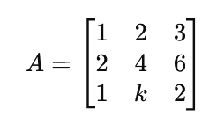  find the value of k for which the rank of A = 2 | (8) | CO2 | KL3
************

